Technical
Document
By Meshaal Mouawad
August 25th, 2025

AI-Powered KPI Extractor & Interactive Bluebook Generator

- Technical Introduction
This section provides a high-level overview of the "AI-Powered KPI Extractor & Interactive Bluebook Generator," its purpose, the technologies used, and how it works.

Introduction
This tool is a sophisticated application of the Literate Programming philosophy, designed to bridge the gap between source code and high-level business documentation. Its primary function is to scan a software project, automatically identify and extract Key Performance Indicators (KPIs) defined within the code, and generate a professional, interactive "Bluebook" website.
By leveraging a Generative AI for natural language descriptions and a robust code analysis engine for mathematical formulas, this tool ensures that documentation remains synchronized with the actual implementation, reducing manual effort and improving the accuracy of technical documentation. An example in shown in Figure. 1, 2, and 3 after the bluebook was generated.
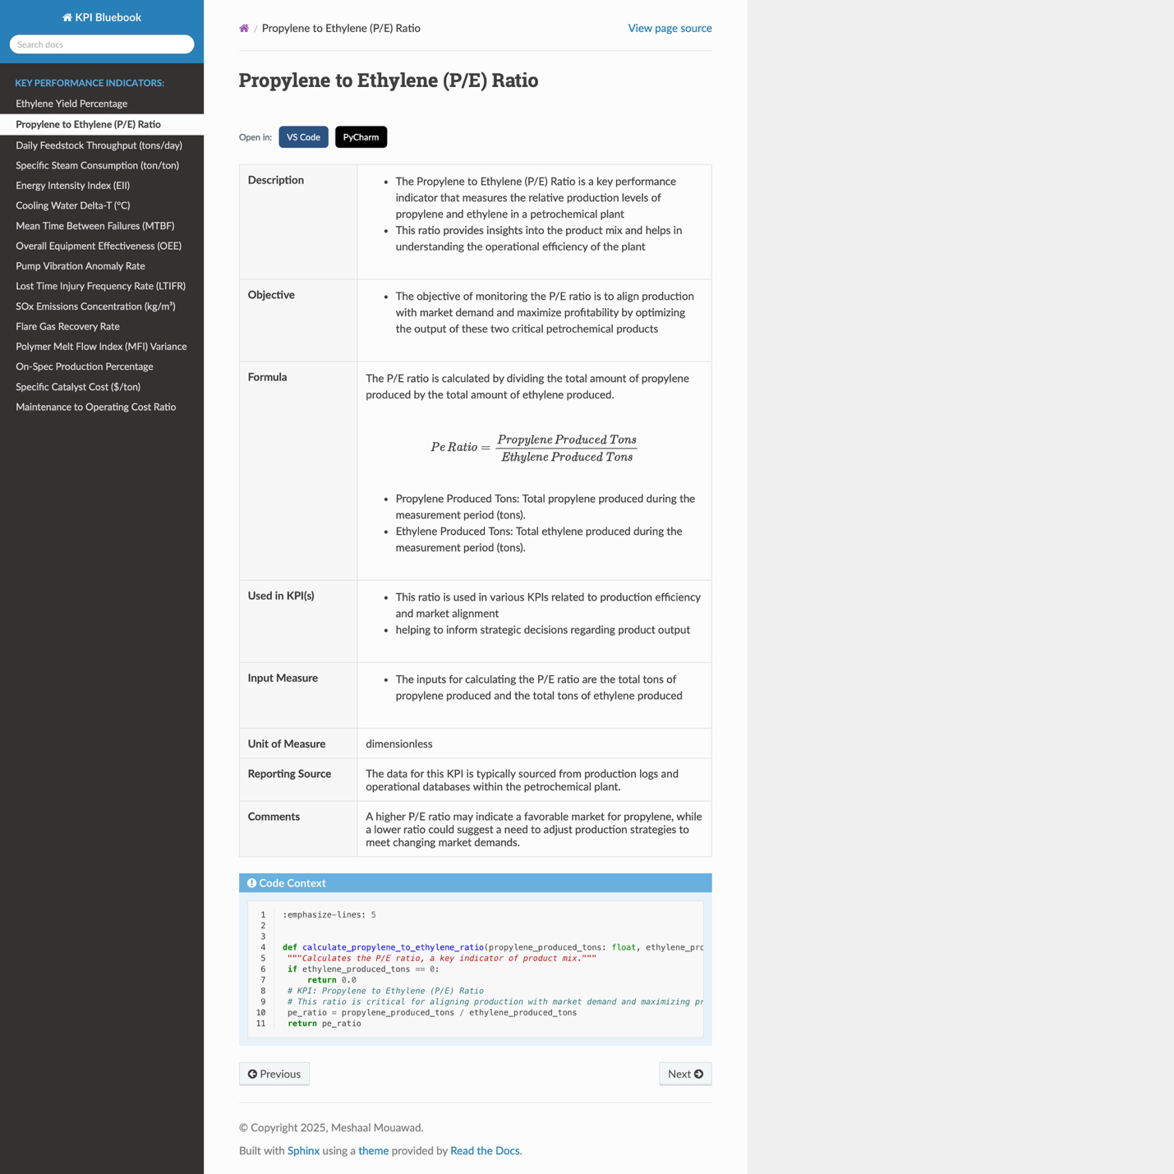Figure. 1. Example of [Propylene to Ethylene (P/E) Ratio] KPI generated by & interactive bluebook that was generated by AI-Powered KPI Extractor & Interactive Bluebook Generator.
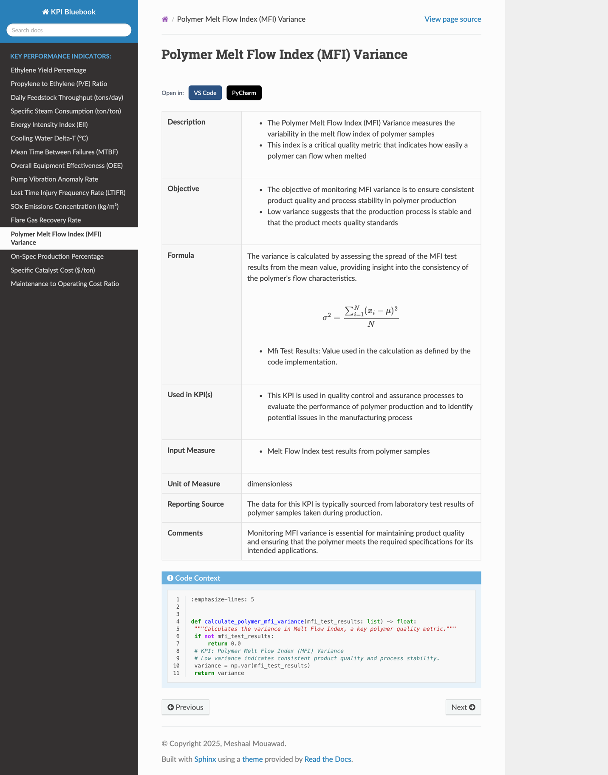Figure. 2. Example of [Polymer Melt Flow Index (MFI) Variance] KPI generated by & interactive bluebook that was generated by AI-Powered KPI Extractor & Interactive Bluebook Generator.
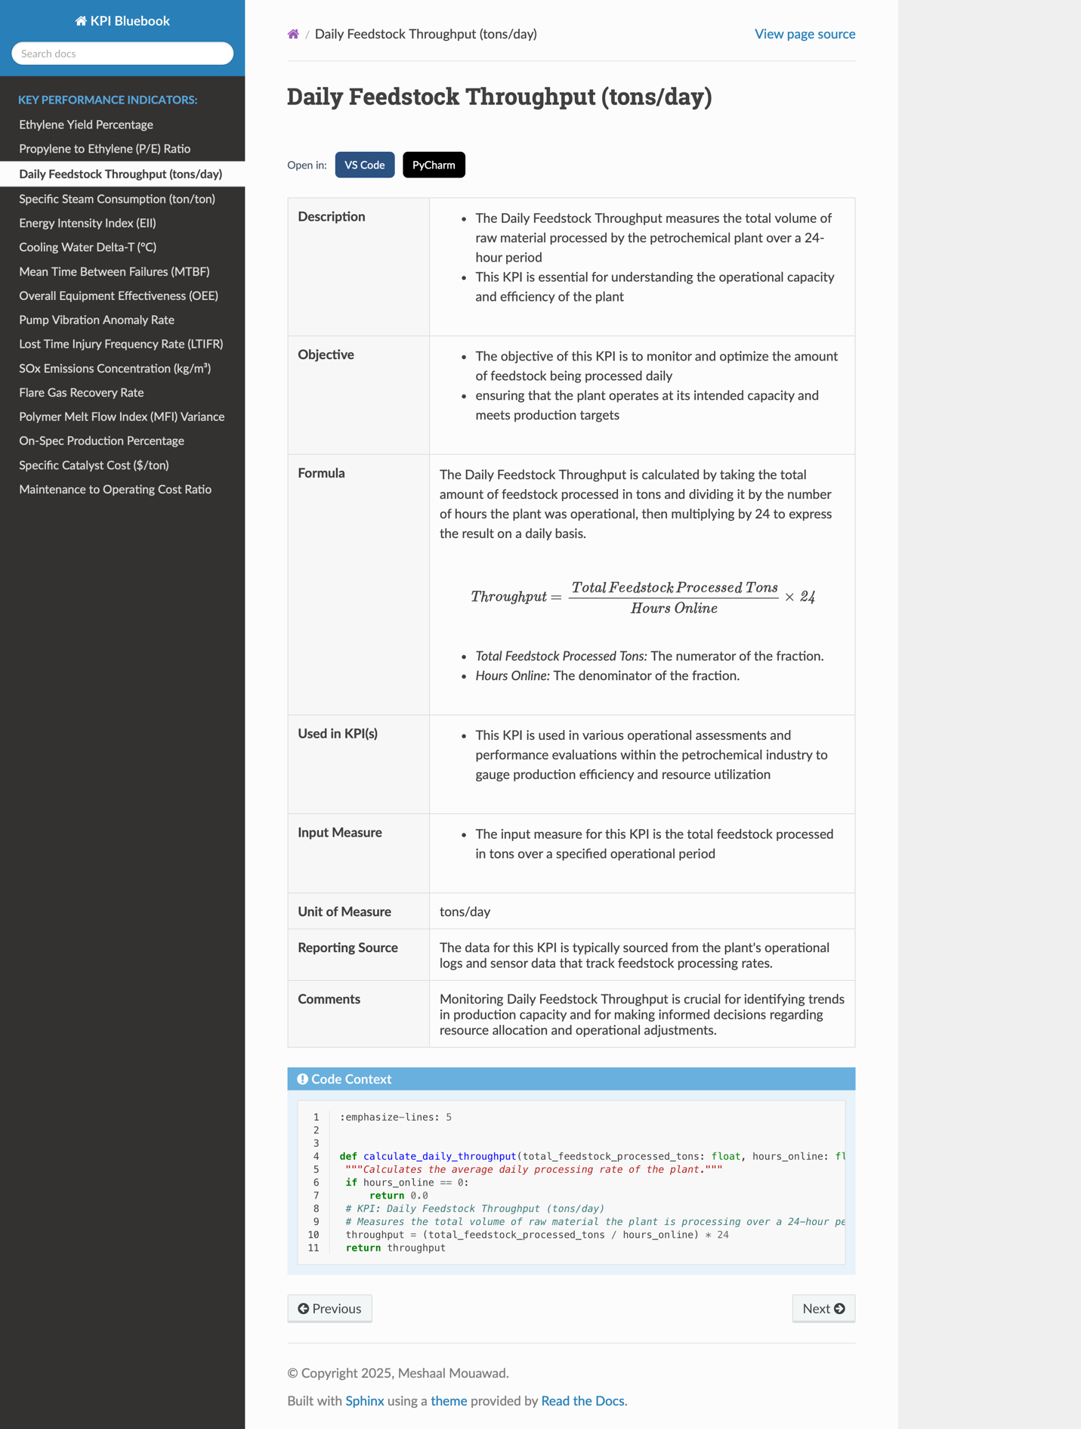Figure. 3. Example of [Daily Feedstock Throughput (tons/day)] KPI generated by & interactive bluebook that was generated by AI-Powered KPI Extractor & Interactive Bluebook Generator.

- Core Technologies
The generator is built on a modern, reliable stack:
- Backend Language: Python 3.9+
- Web Framework: Flask (for the user interface)
- Code Scanning: Custom Python scripts using the os and re modules.
- AI Integration: OpenAI API (specifically the gpt-4o-mini model) for generating rich, context-aware text descriptions.
- Documentation Engine: Sphinx, the de-facto standard for Python project documentation, which builds the final static HTML site.
- Templating: Jinja2 for dynamically creating the source files for Sphinx.
- Frontend: Simple HTML, Tailwind CSS, and JavaScript for a clean and responsive user interface.
- Mathematical Rendering: MathJax, which is automatically integrated by Sphinx to render beautiful LaTeX formulas in the browser.
- System Requirements
To run this application, you will need:
- Python 3.9 or newer.
- The pip package manager.
- An active OpenAI API key with access to the gpt-4o-mini model.
- A modern web browser (Chrome, Firefox, Edge, Safari).
- How It Works
The process is orchestrated by a Flask web application and can be broken down into five main steps:
- User Input: The user provides the absolute path to a software project's directory via a simple web interface.
- KPI Extraction: The Python script (kpi_extractor.py) recursively scans the directory for source code files. It uses regular expressions to find special comment tags (e.g., # KPI: Ethylene Yield Percentage) and extracts the KPI name and the surrounding code as context.
- AI-Powered Description Generation: For each KPI found, the application sends the KPI name and its code context to the OpenAI API. The AI is tasked with generating rich, human-readable descriptions, objectives, and other metadata, which it returns in a structured JSON format.
- Programmatic Formula Generation: To ensure 100% accuracy, the application does not use the AI for mathematical formulas. Instead, a powerful function in main.py programmatically analyzes the extracted code snippet to generate a perfect, clean LaTeX formula.
- Bluebook Compilation: The tool combines the AI-generated text with the programmatically generated formula. It then uses a Jinja2 template (kpi_template.rst.j2) to create a .rst source file for each KPI. Finally, it runs the Sphinx build process, which compiles all the .rst files into a polished, interactive HTML website, complete with a navigation menu, search functionality, and perfectly rendered math equations.

- Project Structure
This section the definitive, and functional structure for the entire project.
KPI_Inrctive_Bluebook/
├── .env # Stores your secret OpenAI API key.
├── .venv/ # Your Python virtual environment folder.
├── app.py # The main Flask web application that you run.
├── bluebook_generator/ # The core Python package for the generator logic.
│ ├── __init__.py # Makes this folder a Python package.
│ ├── ai_generator.py # Handles all interaction with the OpenAI API.
│ ├── kpi_extractor.py # Scans source code to find KPI comment tags.
│ └── main.py # The main logic for generating the bluebook.
│
├── docs/ # The source folder for the Sphinx documentation.
│ ├── _build/ # The final, generated HTML website appears here.
│ ├── _static/ # Folder for custom CSS and other static files.
│ │ └── custom.css # Custom styles for table formatting.
│ ├── conf.py # The main Sphinx configuration file.
│ └── index.rst # The top-level page for the Sphinx site.
│
├── sample_project/ # An example project to analyze.
│ ├── __init__.py
│ ├── petrochemical_plant_operations.py # The complex test file.
│ └── sales_report.py # The original simple test file.
│
└── templates/ # Templates for SPHINX (.rst) files, FLASK WEB UI
├── index.html # The HTML for the main web interface. Flask UI
└── kpi_template.rst.j2 # The Jinja2 template for a single KPI page.

PyCharm
Code structure
- bluebook_generator/ Python package
  - init.py
  - version.py
  - cli.py CLI entrypoint (bluebook)
  - main.py Orchestrates extraction → AI → render → build
  - ai_generator.py AI content (text) + unit inference
  - kpi_extractor.py Finds KPI blocks in source code
  - utils.py Helpers (formatters, IO)
- templates/
  - kpi_template.rst.j2 Sphinx/RST template for each KPI page
- docs/
  - index.rst Auto-updated by generator
- KPI_Inrctive_Bluebook.plantuml UML + Flowchart
- README.md Cookbook + Technical intro

AI-Powered KPI Extractor & Interactive Bluebook Generator
This tool scans your Python code for KPI comments inside functions, generates clean documentation pages with readable math, and builds an interactive HTML “Bluebook” using Sphinx.

Features
- AST-precise “Code Context” (only the function that implements the KPI)
- Programmatic LaTeX/MathJax formulas with italic readable labels and correct operator precedence
- AI-generated descriptions/objectives/notes
- Smart unit-of-measure inference (%, tons/day, hours per failure, ratio, …)
- One-command CLI

Requirements
- Python 3.10+
- virtualenv + pip
- Packages: click, jinja2, requests (installed automatically by your project)
- Sphinx for building docs: pip install sphinx

Install
Bash python -m venv .venv && source .venv/bin/activate pip install -e

If you don’t have a setup.py, simply run from the repo root:
bash python -m bluebook_generator.cli generate path/to/your/source

Set your OpenAI key:
bash 'export OPENAI_API_KEY=sk-...'

How to Use
- Tag KPIs in code inside a function with a single-line comment: 'python def calculate_oee(...): # KPI: Overall Equipment Effectiveness (OEE) oee = availability * performance * quality * 100 return oee'
- Generate: bash 'bluebook generate ./path/to/your/repo'
- Open docs/_build/index.html.

How it Works
- kpi_extractor.py finds # KPI: markers within functions.
- main.py scopes the function with AST, generates MathJax from code, and renders a Jinja template.
- ai_generator.py calls OpenAI to create narrative fields and infers a specific unit when the AI is vague.
- Sphinx converts .rst into an HTML Bluebook.

Customization
- Edit templates/kpi_template.rst.j2 for layout.
- Add rules to ai_generator._infer_unit_of_measure to refine units.
- Extend variable definitions in main.generate_formula_from_code.

Troubleshooting
- Missing API key → set OPENAI_API_KEY.
- “No KPIs found” → ensure # KPI: Your KPI Name is inside a function.
- Broken LaTeX → check expressions or open an issue with the example.

Example KPIs
- Overall Equipment Effectiveness (OEE)
- Ethylene Yield Percentage
- Daily Feedstock Throughput (tons/day)
- Mean Time Between Failures (hours per failure)
- Propylene to Ethylene (P/E) Ratio
Packaging (optional) If you’d like a console script named bluebook, add this to your pyproject.toml or setup.cfg. Example for setup.cfg: [metadata] name = bluebook-generator version = 1.0.0 description = AI-Powered KPI Extractor & Interactive Bluebook Generator
[options] packages = find: install_requires = click jinja2 python-dotenv openai sphinx
[options.entry_points] console_scripts = bluebook = bluebook_generator.cli:main

- UML Diagram & Flowchart
This section contains a high-level UML Component Diagram and a detailed flowchart explaining the application's workflow.

System Diagrams

1. UML Component Diagram
This diagram shows the major components of the system and their relationships.

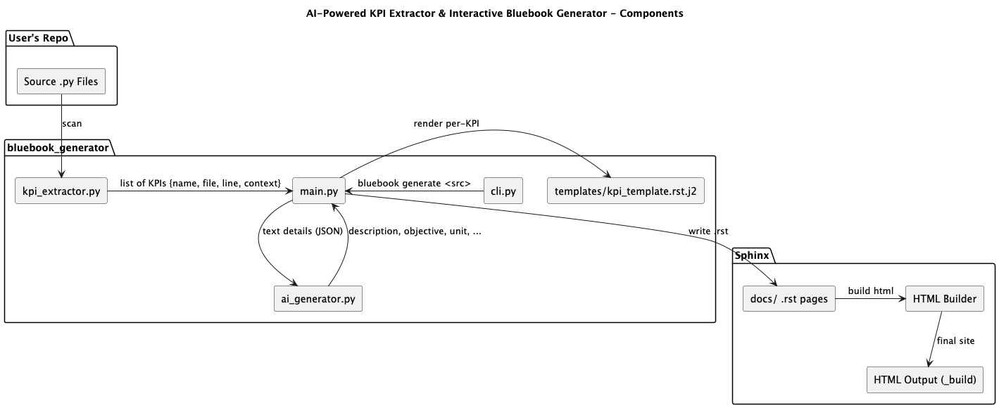

Figure. 4. AI-Powered KPI Extractor & Interactive Bluebook Generator Diagram Component.

2. Application Flowchart
This flowchart details the step-by-step process from user input to final output.
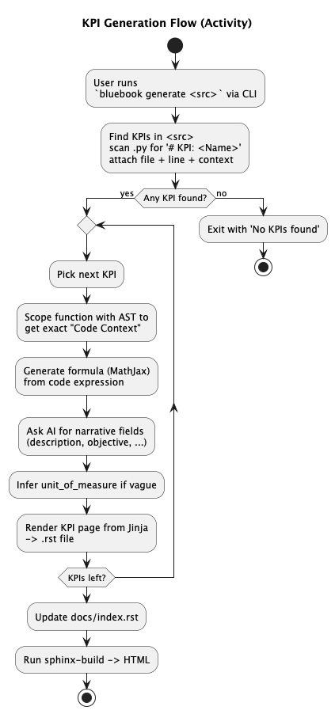
Figure. 5. The flowchart of the AI-Powered KPI Extractor & Interactive Bluebook Generator.

- Cookbook: A Guide to the KPI Bluebook Generator
This section guide provides simple, step-by-step instructions for setting up and running the application.

Cookbook (User Guide)
This is a step-by-step guide for setting up and using the application.

1. Prerequisites
Before you begin, ensure you have the following installed on your system:
- Python 3.9 or newer.
- pip (Python's package installer).

2. Installation
- Get the Code: Download and unzip the project folder, or clone it using Git.
- Navigate to Project Directory: Open your terminal or command prompt and navigate into the project's root folder (KPI_Inrctive_Bluebook/).
- Create Virtual Environment: It's highly recommended to use a virtual environment to manage dependencies. Run the following commands:
- python3 -m venv .venv
- source .venv/bin/activate # On macOS/Linux
- # .venv\Scripts\activate # On Windows

- Install Dependencies: Install all the required Python libraries from the requirements.txt file.
- pip install openai sphinx sphinx_rtd_theme jinja2 flask python-dotenv

3. Configuration
The only configuration step is to provide your OpenAI API key.
- Create the .env file: In the root directory of the project, create a new file named .env.
- Add Your API Key: Open the .env file and add your OpenAI API key in the following format:
- OPENAI_API_KEY='sk-YourSecretKeyGoesHere'

Save the file.

4. Running the Application
- Start the Web Server: From the root directory of the project (with your virtual environment activated), run the following command:
- python app.py

- Open the Web Interface: Your terminal will show a message indicating that the server is running, usually on http://127.0.0.1:5000. Open this address in your web browser.

5. How to Generate a Bluebook
- Enter the Path: In the web interface, you will see a text box. Enter the full, absolute path to the source code folder you want to analyze (e.g., /Users/yourname/KPI_Inrctive_Bluebook/sample_project).
- Click Generate: Click the "Generate Bluebook" button.
- Monitor Progress: The log window will show the real-time progress of the generation, including KPI extraction, AI calls, and the final Sphinx build.
- View the Result: Once the log shows "--- Bluebook Generation Complete! ---", a link will appear at the bottom of the page. Click "View Your Generated Bluebook →" to open the new documentation in a new tab.
That's it! You have successfully generated an interactive KPI Bluebook from your source code.

